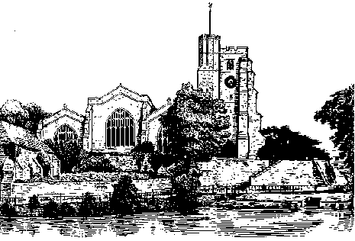
All Saints Church
Mill Street
Maidstone ME15 6YE

Please complete this form and return it to
Lionel Marchant, 7 The Platt, Sutton Valence, Maidstone, ME17 3BQ
Take a copy of the completed form and keep it for your records
Sing Around Christmas
with Derek Blease
Thursday 1st December 2016
Friday 2nd December 2016

Once again years 3, 4, 5 and 6 are invited to All Saints for a celebration of Christmas with music led by Derek Blease. As in previous years there will be two events in which All Saints seeks to offer an opportunity for children from local schools to come together and sing Christmas carols in the Parish Church of our County Town. The participation cost for 2015 is £30.00. This will include a music booklet and a CD. Please complete and return this application form with your school cheque for £30.00 to Lionel Marchant at the address shown above. Cheques should be made payable to All Saints with St. Philip Fee Account.

As part of our Child Protection policy schools are asked to ensure that all teachers and TAs accompanying the children wear their school ID badge where it can be easily seen.

You need to be aware that events in All Saints church are public events and might attract the attention of the media. Therefore photographs might be taken and video recordings made.

Timetable
10.15am Arrive at the church
10.30am Rehearsal
12 noon Lunch - packed lunches may be eaten in the church if required.
Toilet arrangements. As well as All Saints toilets located in the College Room arrangements have been for the toilets in Maidstone Baptist Church to be available. This will involve crossing under supervision College Road and Knightrider Street at the Pelican Crossings.
1.15pm Assemble in the church
1.30pm Performance
2.30pm Dismissal

There will be carols for all schools to sing plus traditional carols for schools and audience.

Schools are invited to publicise this event to parents and friends and ask them to come to the performance at 1.30pm. The entry charge will be £2.00 (accompanied children free) and there will be a collection during the performance which will be donated to chYps (a children’s health charity see www.chyps.org ) and All Saints Church.

Name of School.......................................................Name of contact...................................................................
E-mail address…………………………………………………………………………………………………..

Preferred date..........................................................How many children will attend............................................

